Synthesis of Compounds with Wound Healing Properties

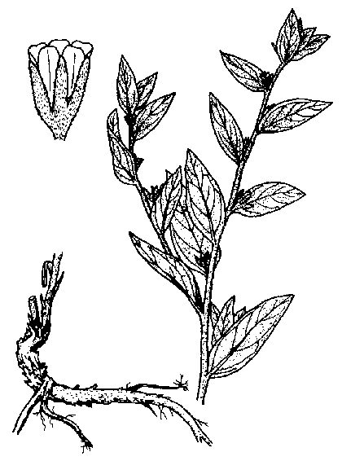
Shikonin is a red compound found in the roots of the plant Lithospermum erythrorhizon which grows in Asia. Extracts of the root have been used for centuries in folk medicine and are used today in ointments for healing of wounds.

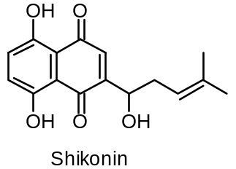

1-1 How many stereoisomers of Shikonin are possible ?

1-2 Do all stereoisomers of Shikonin have the same melting point ? | yes | no
Mark with an X.

The following sequence is part of a synthetic route to Shikonin:

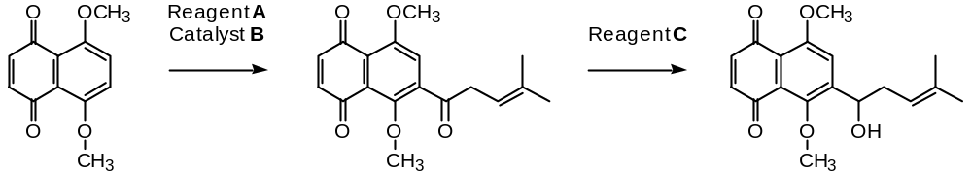

1-3 Draw the structural formula of reagent A.

1-4 Indicate (by means of an X in the appropriate check-box) the correct IUPAC name for reagent A.

2-Methyl-2-pentenoyl chloride
1-Chloro-4-methyl-3-pentene
4-Methyl-3-pentenoyl chloride
4-Methyl-3-pentene-1-ol
4,4-Dimethyl-3-butenoyl chloride

1-5 Write the molecular formula of reagent C.

Numerous Shikonin analogues have been synthesized with a view to obtaining more potent compounds. One reaction sequence is shown below:

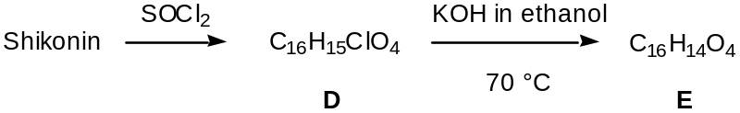

1-6 Draw the structural formula of compound E.

1-7 How many stereoisomers of compound E, if any, are possible

Another route to useful Shikonin analogues is the following:

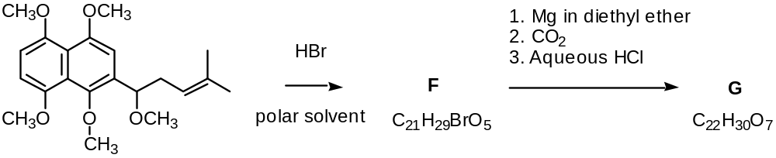

1-8 Draw the structural formula of compound F.

1-9 Draw the structural formula of compound G.

